Results

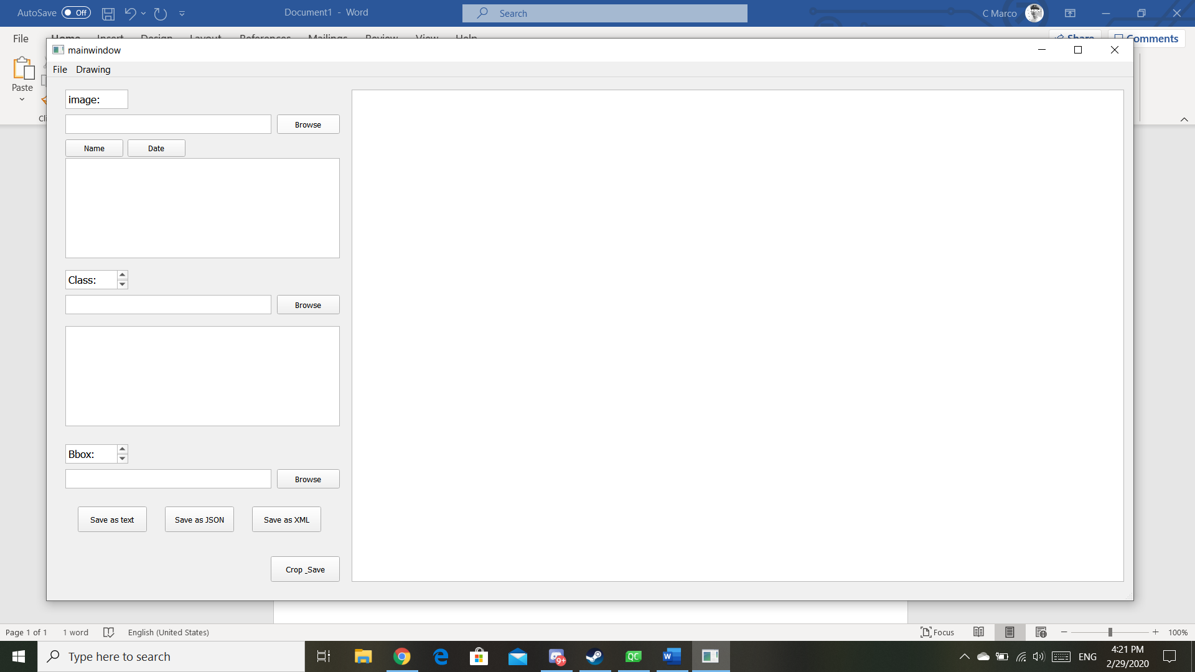

(a simple gui for the label app)

Clicking the browse button in the image section will bring user to folder browse interface. It’s default destination was C://.

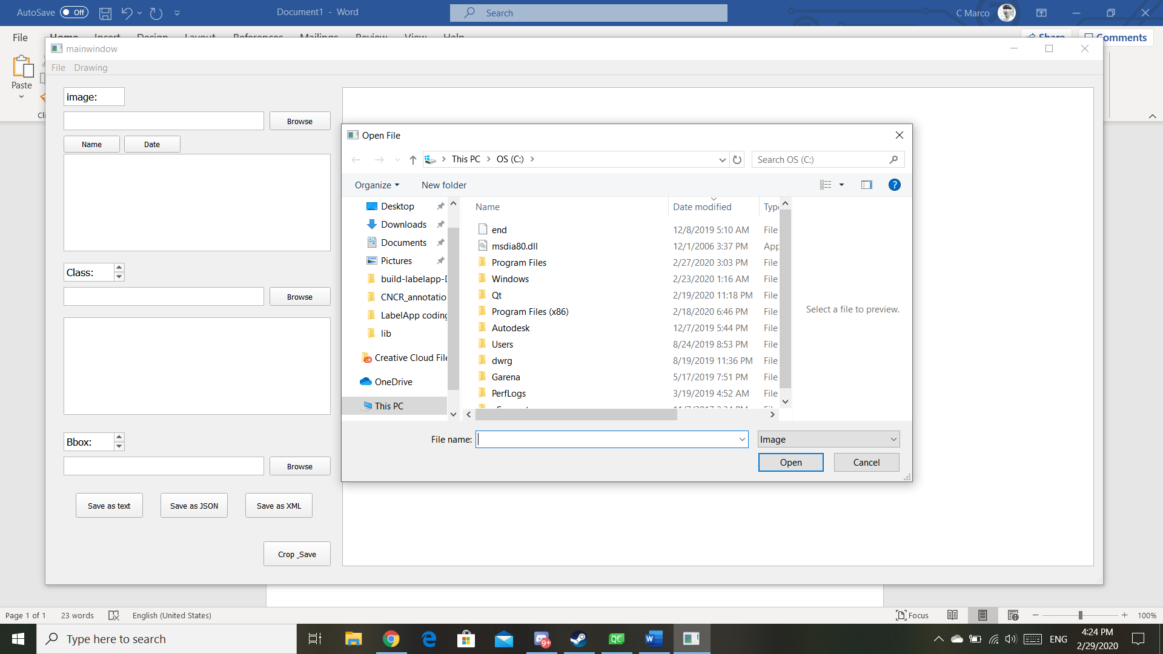

This is simply the folder after clicking browse button on the label app gui.

User will have to select image in .jepg and .png and the image will display in the graphics view frame as below.

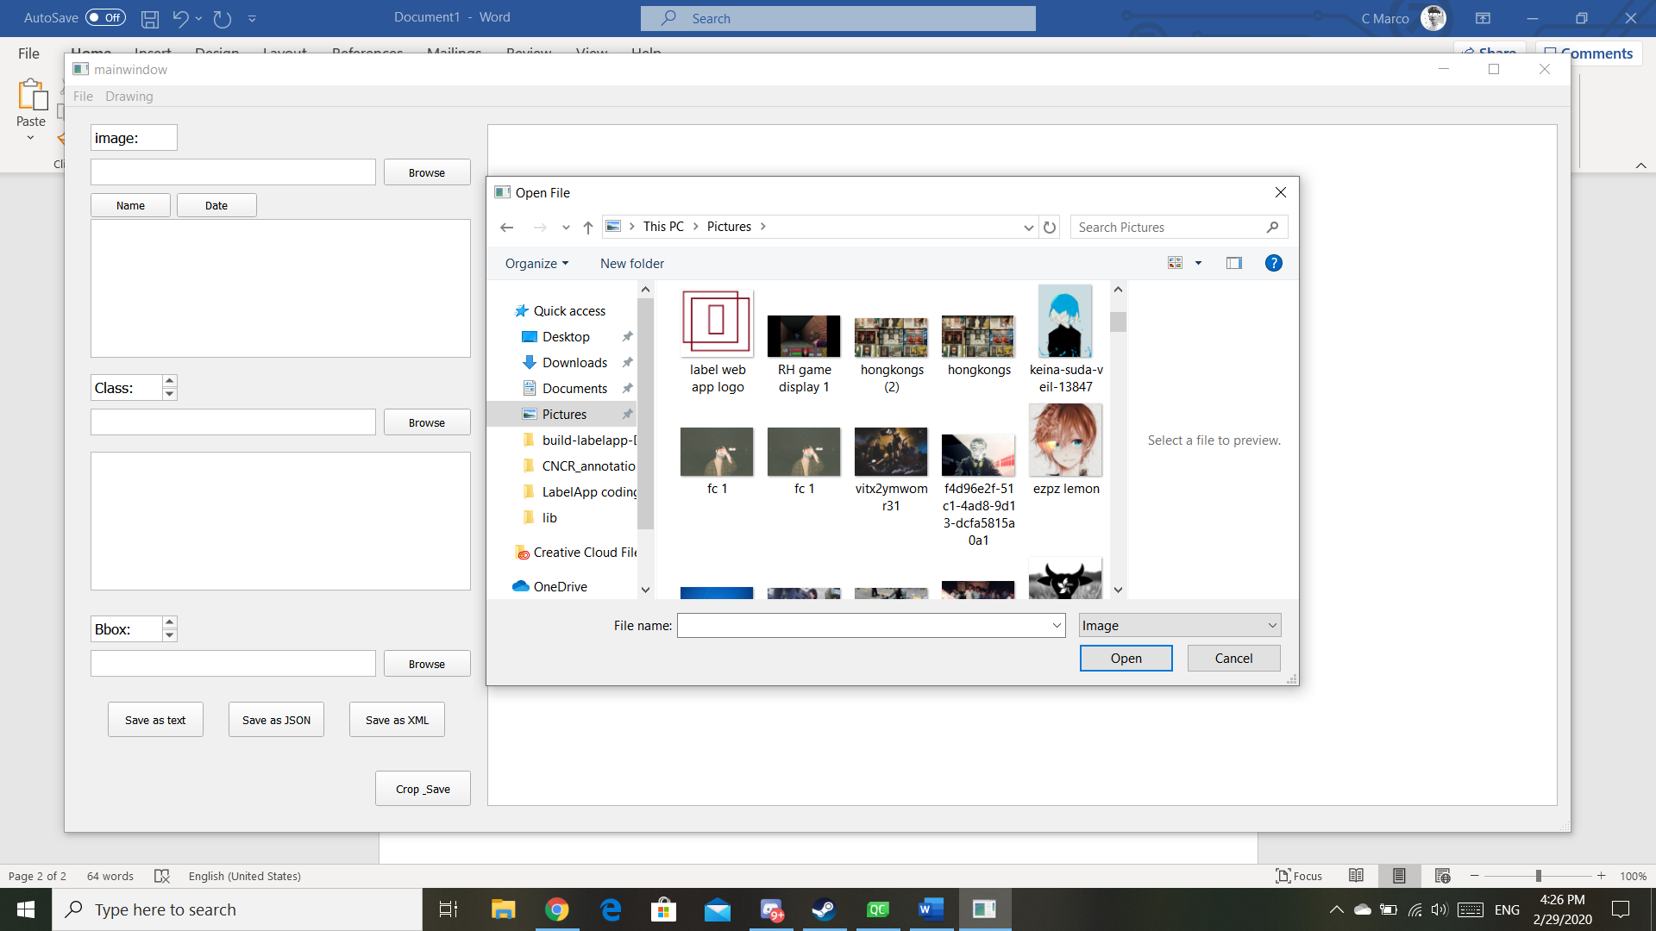

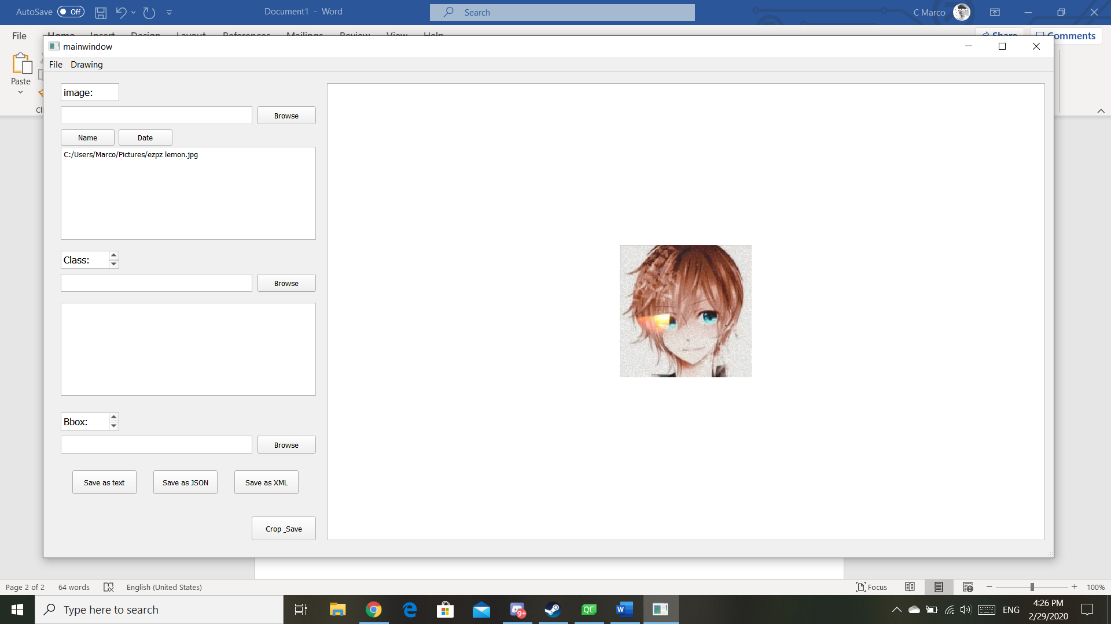

Selected image(file name) will be displayed in the text browser field to let user know the image file selected.

Afterwards, user can zoom in and out to a specific point of the picture users prefer using mouse wheel.

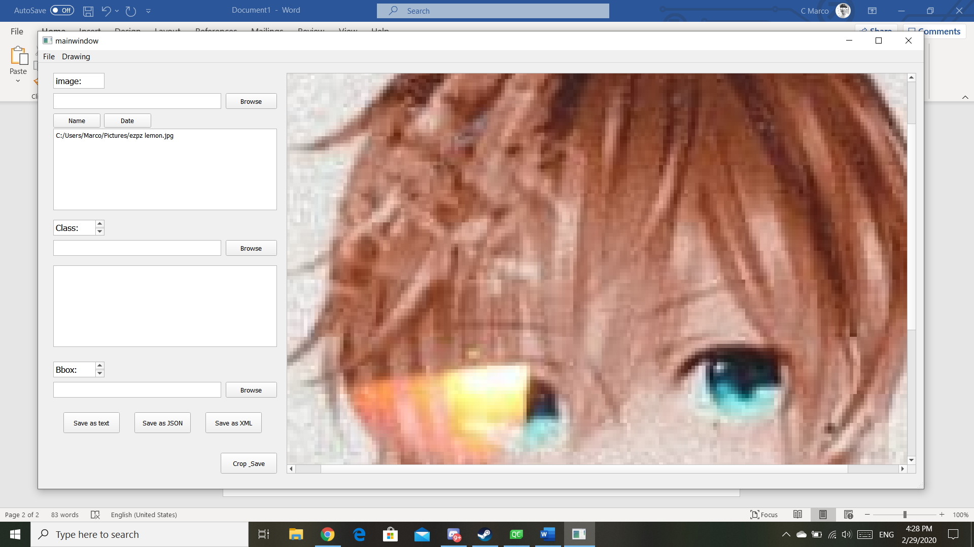

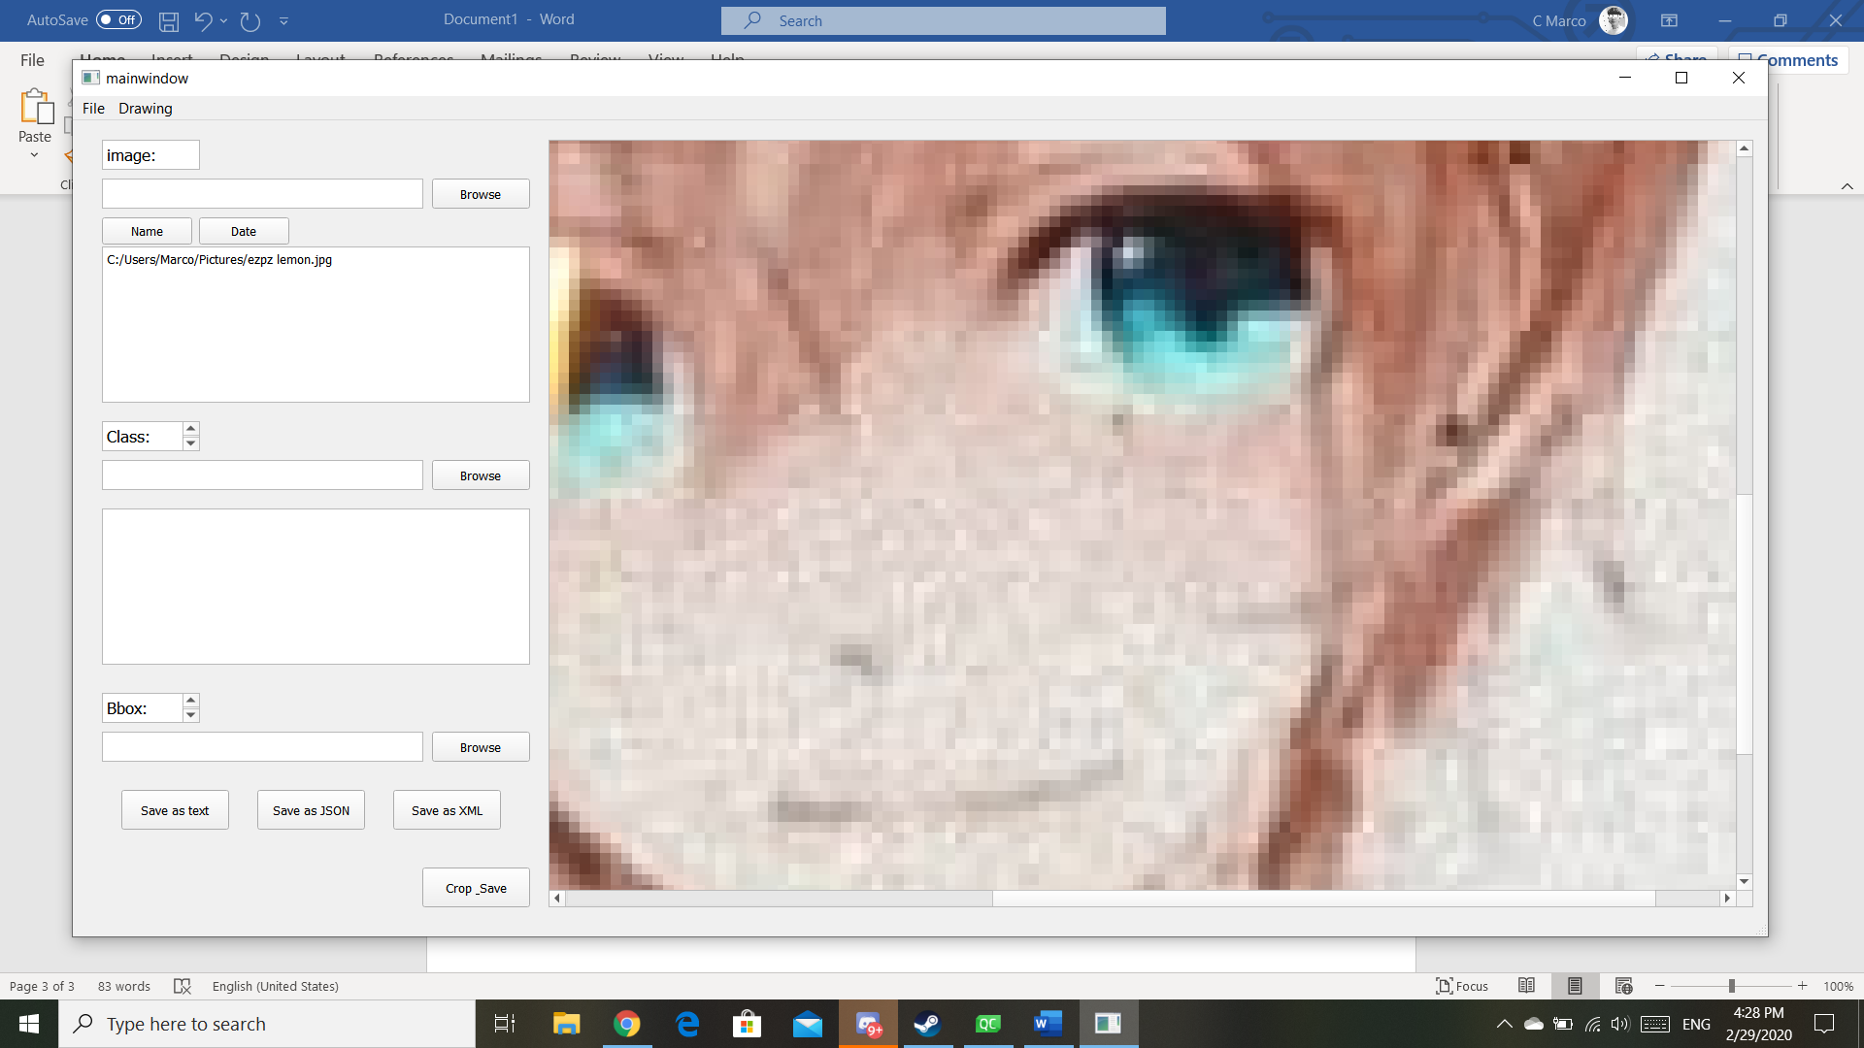

And if the image was too big in the graphic view frame, there will be a scroll to move around the picture to ensure users are able to see the rest of the picture after it was zoomed in.